55

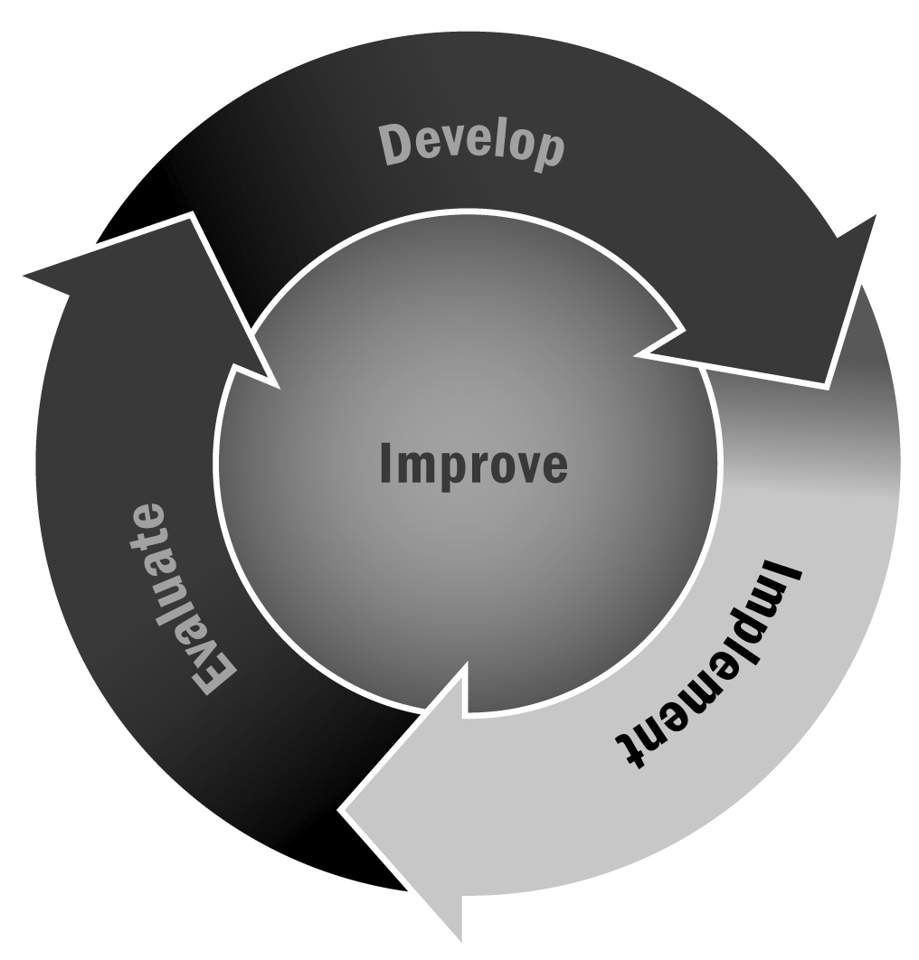
Family Engagement and Interest Survey
In Chapter 3, you learned about the importance of involving family members in your program planning. Surveying family members about their interests and how they would like to be engaged in your program will allow you and your staff to offer programming that is most useful to families.
Directions: The survey on the following pages will help you determine how families want to be engaged on behalf of their children, on their own behalf, and on behalf of the program (i.e., as volunteers). You can use and adapt this survey in its entirety or pull sections out as needed during your program cycle. Be sure to personalize the survey by filling in the missing information wherever indicated.

Tips for Developing and Administering Surveys (For a Full List, See Tool 87)
- Consider your goals and expected outcomes for the survey. What are you trying to learn? Design a survey and develop questions that will help you achieve those goals and answer your ultimate question.
- Make sure you are familiar with the legal and institutional requirements, if any, when surveying families, community members, and especially youth.
- Prioritize your selection of survey questions.
- Consider your audience and make sure your survey will be understood easily.
- Write short questions that respondents can read quickly and easily.
- Make sure that each question has one central idea.
- Focus your questions on suggestions for improvement rather than focusing on negative experiences.
- Avoid leading questions that appear to advocate a particular answer.
- Provide instructions on how to record answers and how many options to select.
- For multiple choice questions, allow respondents to select “other” so they can write in another response that wasn’t included.
- Test your survey with a small group before distributing it to all of your intended respondents.
- Think about how you will deliver the survey. Will it be delivered by mail, by telephone, in person, or online? These different methods will affect the survey design. It is likely that a paper survey will be the most convenient method for respondents, but an electronic survey has advantages as well (such as allowing for skip logic and requiring less data entry) if it seems like a viable format for your respondents.
- Provide respondents with a contact person whom they can reach if they have any questions or concerns about the survey.

Dear Families,
We need your help! We want to create an afterschool and expanded learning program that is engaging for your child and for you. Please tell us what activities you think we should offer and when, and let us know what role, if any, you would like to play in the afterschool and expanded learning program. This survey will take only a few minutes to fill out.
If you have questions, please contact [name] at [telephone] or [email]. Please complete this survey by [date].
- Would your child or children participate in an afterschool and expanded learning program?
- Yes
- No
- What types of activities do you think an afterschool and expanded learning program at our school should offer? (Rank your top eight choices from 1 to 8, with 1 as your top choice.)
 | Chess |  | Aerobic exercise |  |  | Arts and crafts
 | Community service |  | Basketball |  |  | Card and board games
 | Computer club |  | Cheerleading |  |  | Cooking
 | Homework help or tutoring |  | Gymnastics |  |  | Dance
 | Junior achievement |  | Martial arts |  |  | Drama
 | Photography |  | Soccer |  |  | Field trips
 | Poetry writing |  | Softball/baseball |  |  | Music
 | Peer counseling/conflict resolution |  | Volleyball |  |  | Woodworking
 | School newspaper |  | Yoga
 | Science experiments |  | Other:
- How much would you be willing or able to pay per child for an afterschool activity that met [X] times a week for [X] weeks (a total of [X] sessions)? ________________
- Please indicate the days and times that you would like your child or children to be able to attend activities. (Check all that apply.)
❒ | Monday | ❒ | Friday | ❒ | Before school
❒ | Tuesday | ❒ | Saturday | ❒ | After school
❒ | Wednesday | ❒ | Sunday | ❒ | During school vacations
❒ | Thursday |  |  | ❒ | During the summer
- How would your child go home after the program activities end? Would he or she need transportation?
❒ | Yes, I would need the program to provide transportation for my child or children after an activity.
❒ | No, I would be able to pick up my child or children after an activity.
❒ | No, my child or children can walk home after an activity.
❒ | No, older siblings can pick up my child or children after an activity.
❒ | No, I belong to a carpool group with other families that have youth in this program.
Other:

- Would you participate in adult programming?
- Yes
- No
- What types of courses would interest you? (Rank your top five choices from 1 to 5, with 1 as your top choice.)
 | Academic content areas
❒ | English language arts |  | ❒ | Science/science, technology, engineering, math (STEM)
❒ | Math |  | ❒ | History/social studies
 | Homework help |  |  | Social and emotional well-being
 | Tutoring |  |  | Sports
 | Computer/technology skills |  |  | Physical fitness
 | Creative arts |  |  | Service learning
 | Healthy living |  |  | Cultural appreciation and diversity
 | Other, please specify:
- How much would you be willing or able to pay per course if it met [X] times a week for [X] weeks? ________
- Please indicate the days and times that you would be able to attend.
 | Example | Sun | Mon | Tue | Wed | Thu | Fri | Sat
From: | 4:00 p.m.
To: | 6:00 p.m.
Exceptions: | First week of the month
- Would you need transportation in order to attend an adult education course?
- Yes, I would need the program to provide transportation for me.
- No, I don’t need transportation.
- Are you interested in volunteering to help with the adult education program?
- Yes
- No
- In what ways would you like to volunteer? (Check all that apply.)
❒ | Teach a class |  | ❒ | Help a staff member with a class
❒ | Help with paperwork (e.g., keep attendance, fill out forms) |  | ❒ | Help market the program (e.g., write for the newsletter, pass out flyers)
❒ | Greet participants and answer questions |  | ❒ | Provide help wherever needed
❒ | Other, please specify:
- Are you interested in volunteering to help with our program?
- Yes
- No
- If yes, how would you like to volunteer? (Check all that apply.)
❒ | Teach a class or activity with youth |  | ❒ | Join the family advisory group
❒ | Help a staff member with a class or activity with youth |  | ❒ | Join the organization/program advisory board
❒ | Greet young people and answer questions |  | ❒ | Help with paperwork and other administrative tasks
❒ | Teach a class or activity with adults |  | ❒ | Support fundraising efforts
❒ | Help a staff member with adult programming activities |  | ❒ | Help market the program (e.g., write for the newsletter, pass out flyers)
❒ | Other, please specify:
- Are there specific content areas or skills that you could contribute to our program?
 | Academic content areas
❒ | English language arts |  | ❒ | Science/science, technology, engineering, math (STEM)
❒ | Math |  | ❒ | History/social studies
 | Homework help |  |  | Social and emotional well-being
 | Tutoring |  |  | Sports
 | Computer/technology skills |  |  | Physical fitness
 | Creative arts |  |  | Service learning
 | Healthy living |  |  | Cultural appreciation and diversity
 | Other, please specify:
- Please indicate when you would be available to volunteer with the program.
 | Sun | Mon | Tue | Wed | Thu | Fri | Sat
From:
To:
Exceptions:

Personal Information
Your name:
Address:
Email:
Telephone:
Best time of day to reach you at this telephone number:
Your child’s/children’s name(s) and grade(s):
Name: |  |  |  |  | Grade:
Name: |  |  |  |  | Grade:

Thank you.

